# Exercise: Inheritance

Problems for exercise and homework for the ["C# OOP" course @ SoftUni"](https://softuni.bg/trainings/2244/csharp-oop-february-2019).

You can check your solutions here: <https://judge.softuni.bg/Contests/1500/Inheritance-Exercise>

**Use** the **provided** **skeleton** for each of the exercises.

## Need for Speed

NOTE: You need a public class **StartUp**. Create the following **hierarchy** with the following **classes**: 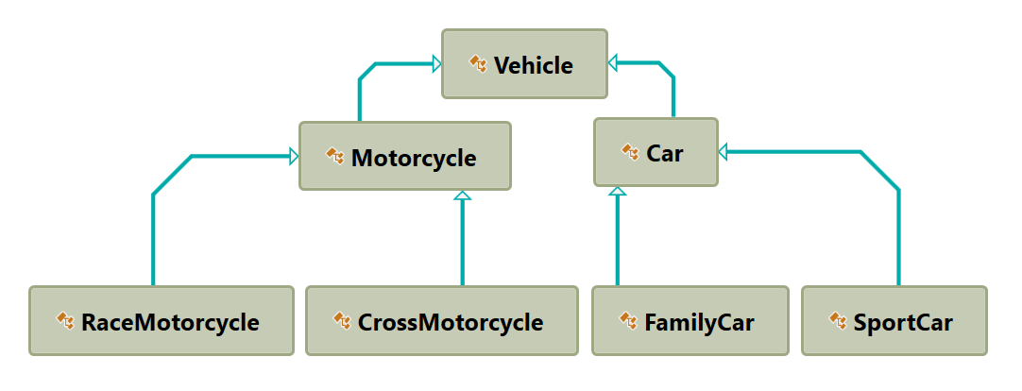

Create a base class **Vehicle**. It should contain the following members:

* A constructor that accepts the following parameters: **int horsePower**, **double fuel**
* **DefaultFuelConsumption – double**
* **FuelConsumption – virtual double**
* **Fuel – double**
* **HorsePower – int**
* **virtual void Drive(double kilometers)**
  + The **Drive** method should have a functionality to reduce the **Fuel** based on the travelled kilometers.

The default fuel consumption for **Vehicle** is **1.25**.Some of the classes have different default fuel consumption values:

* **SportCar – DefaultFuelConsumption = 10**
* **RaceMotorcycle – DefaultFuelConsumption = 8**
* **Car – DefaultFuelConsumption = 3**

Zip your solution without the bin and obj folders and upload it in Judge.